Installation on Windows

Step 1.Download Python 2.7 Windows Installer from the web site(Windows x86-64 MSI installer if you have a 64 bit machine):

https://www.python.org/downloads/release/python-2713/

Step 2. Download the zip file ImageTagVER.zip
Unzip it and place it anyware on your computers

Step 3 Open The Python GUI
Select file→open→ select the folder in 2. main.py

click on execute ….

Instruction of how to use ImageTagVER

Install in Linux

2. Create the Folders

Download VERImgeTag.zip
unzip the files into your personal documents

Recommended to Create the following folders:
images/ Where the original RGB images will be saved. Mist contain the image you want to tag
annotations/ where the xml PASCAL VOC files for tensorflow will be saved, empty at the beginning
out/ where where the tagged images will be saved, empty at the beginning

3. USEOpen terminal

Linux: ctrl+T
Mac
Window

On the terminal type $ python main.py

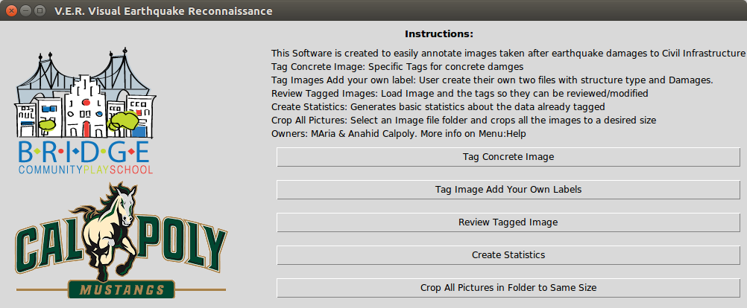

1. Tag Concrete Image

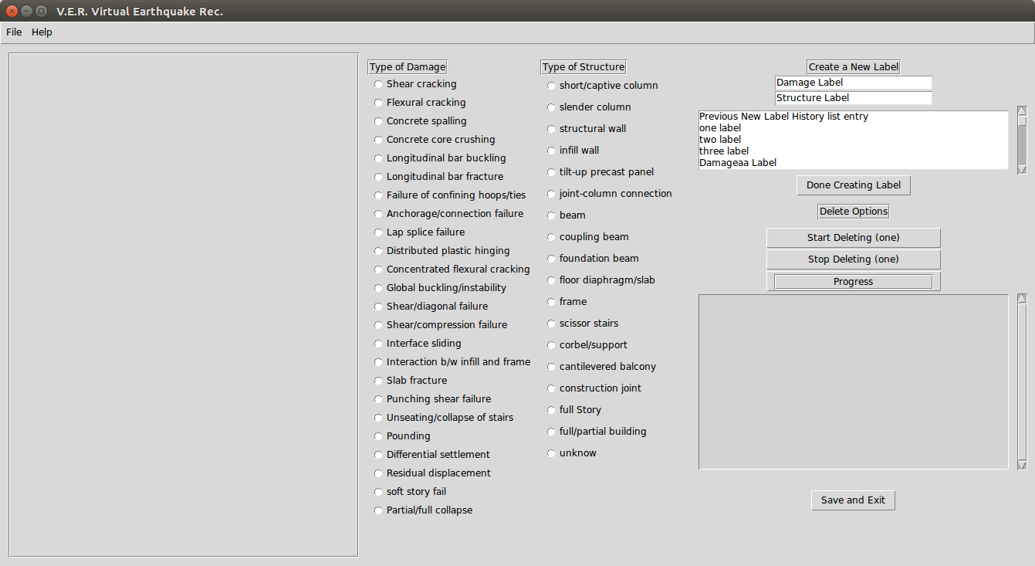
On Top Left corner select File→open file (select the image you want to tag)
On Top Left Conner select File→select output folder (select the folder where you want to save all outputs)

Select one of the TypeofDamage radio buttons and a TypeofStructure radio button and click/drag on the image selecting the area you are interested on
The labels you select will be shown on the Histtory Console ListBox

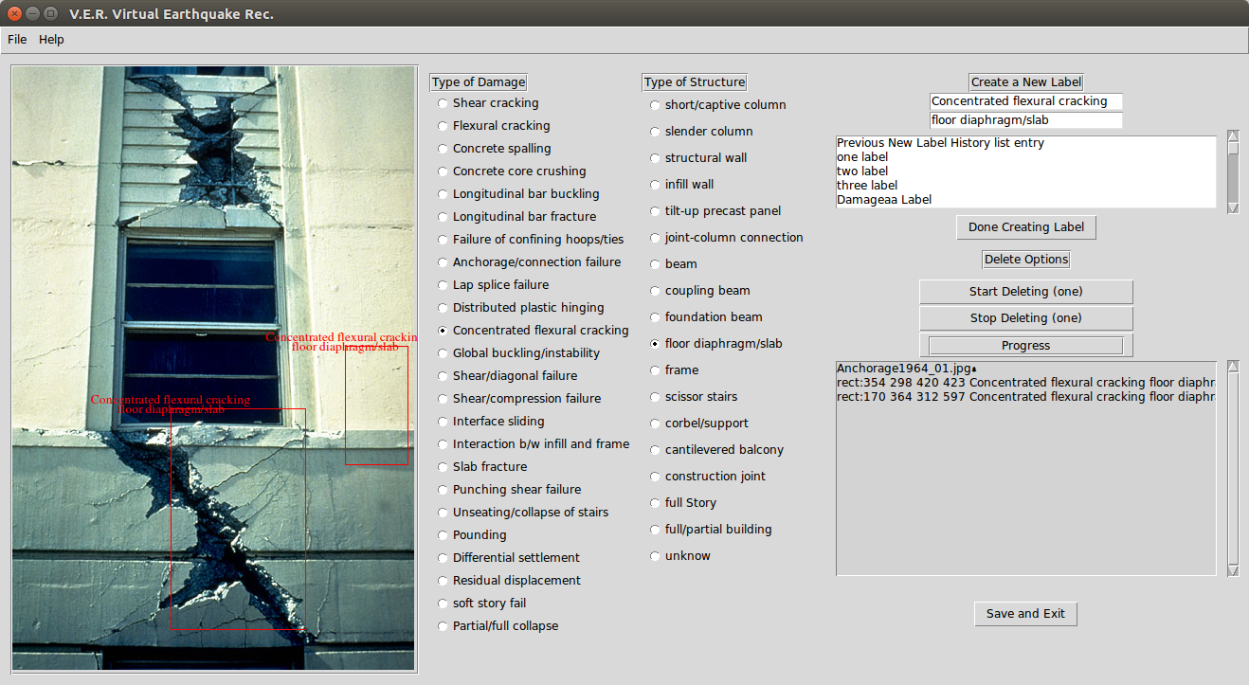

You can create your own labels by entering the names on the top left create new label Input box, the previously created labels will be displayed in the listbox under. You must click on the Done creating new label so it gets saved for future use

If you made a mistake and want to erase some of the lebels click on the button Start Label Erase and then click on the Top Left corner of the rectangle containing the label. Once you are done erasing the mistakes select the Stop deleting label

Click on Save and exit when done

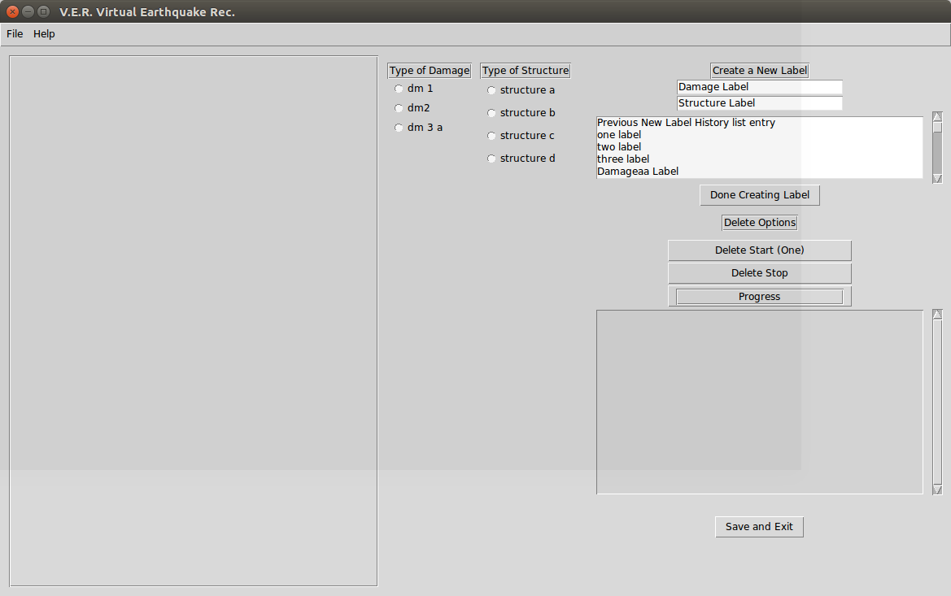
When you click on TagImage add your own labels you will be ask for the location of the Damages (DM.txt) and then the location of the structures (ST.txt) . After that the functionality is exactly the same as in 1.

3. Review ImageTag

If you want to review somebody elses tag and erase/add some of the labels
1. Select File→open original file
2. Select output folder

3. Select Tagged text file (output.txt)

After this functionality is as 1

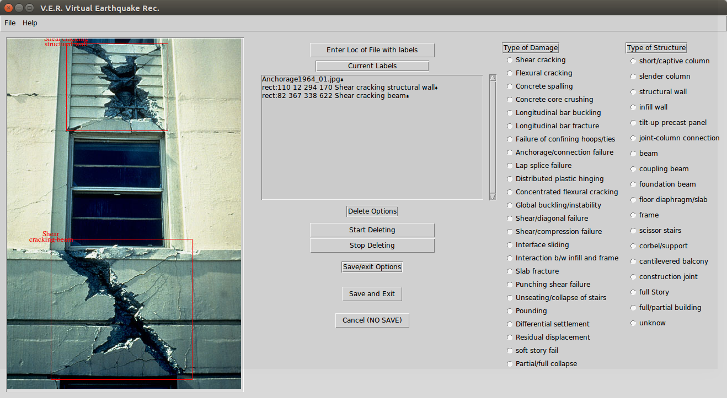

4. Create Statistics

By now just creates the Histogram of the labels

5. Crop all Images from a folder

Input Folder: contains images
Output folder: Location to save the croped files

